COMPUTER SUBJECT: NETWORK SECURITY

TYPE: GROUP WORK

IDENTIFICATION: Kali-Tools/MICL

COPYRIGHT: Michael Claudius

LEVEL: INTERMEDIATE

DURATION: 2 hours - 1 month

SIZE: 200 lines!!

OBJECTIVE: Various tools for sniffing, spoofing etc.

REQUIREMENTS:

COMMANDS:

IDENTIFICATION: Kali-Tools/MICL

Prolog
You have successfully finalized the IT-Security course. You will like to investigate more!.

The Mission
You are to discuss and apply different techniques to break network security.

Purpose
The purpose is to apply various tools on Kali-Linux and to understand how to spoof, sniff others on the net.

Installation of Kali Linux
There are several ways of skinning a cat and that’s also the case when installing SW:

- Install Kali-Linux besides your Windows 10.
I don’t recommend this. Complicated and also your actions are easily tracked !!

- Install Kali-Linux like you installed Ubuntu on Virtual-Box, the iso-file (64 bit HTTP version) can be downloaded from https://www.kali.org/downloads/
This is ok, the file size is 3.3G. Remember to use fixed size disk 20 Giga space.
Recommended if c) does not work out.

- Even better download the ova-file (prepmade VT-box image) from https://www.offensive-security.com/kali-linux-vm-vmware-virtualbox-image-download/
Really nice the file is 3.9 G And it will take around 15 minutes.
It is explained in Assignment 1. Strongly Recommended.
IF the net is too slow your teacher has a few USB-stick with the file!

- Alternatively you can install Kali tools on your Ubuntu-server, this is explained in Appendix A. Not Recommended at all (I tried!). Also it is slower.

Useful links
http://www.windowsecurity.com/articles-tutorials

http://www.kalitutorials.net/
http://www.kalitutorials.net/2013/08/kali-linux.html

http://www.hackingtutorials.org/wifi-hacking-tutorials/top-10-wifi-hacking-tools-in-kali-linux/

http://tools.kali.org/

http://www.techrepublic.com/article/pro-tip-install-kali-linux-tools-on-ubuntu-with-this-easy-script/

http://www.tecmint.com/install-kali-linux-tools-using-katoolin-on-ubuntu-debian/

Assignment 1: Installation of Kali Linux on VirtualBox
Goto https://www.offensive-security.com/kali-linux-vm-vmware-virtualbox-image-download/
Find and click: Kali Linux VirtualBox Images
Click: Kali Linux VBox 64 Bit Ova

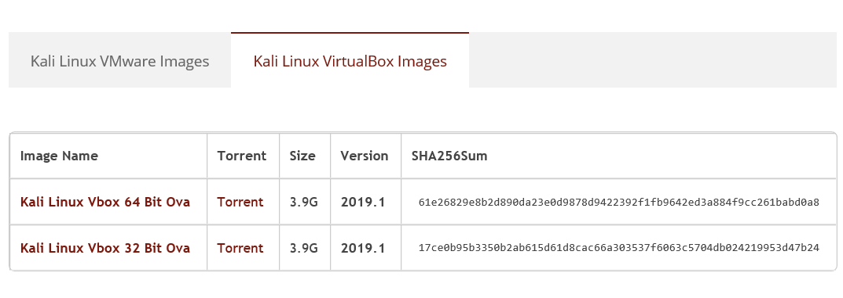

When downloaded, open VirtualBox.
Choose: File -> Import Appliance
And state the .ova file.

Start Kali Linux,
If case of a USB 2.0 error change Settings of Kali Linux to diable USB Controller or choose USB 1.0 Controller.

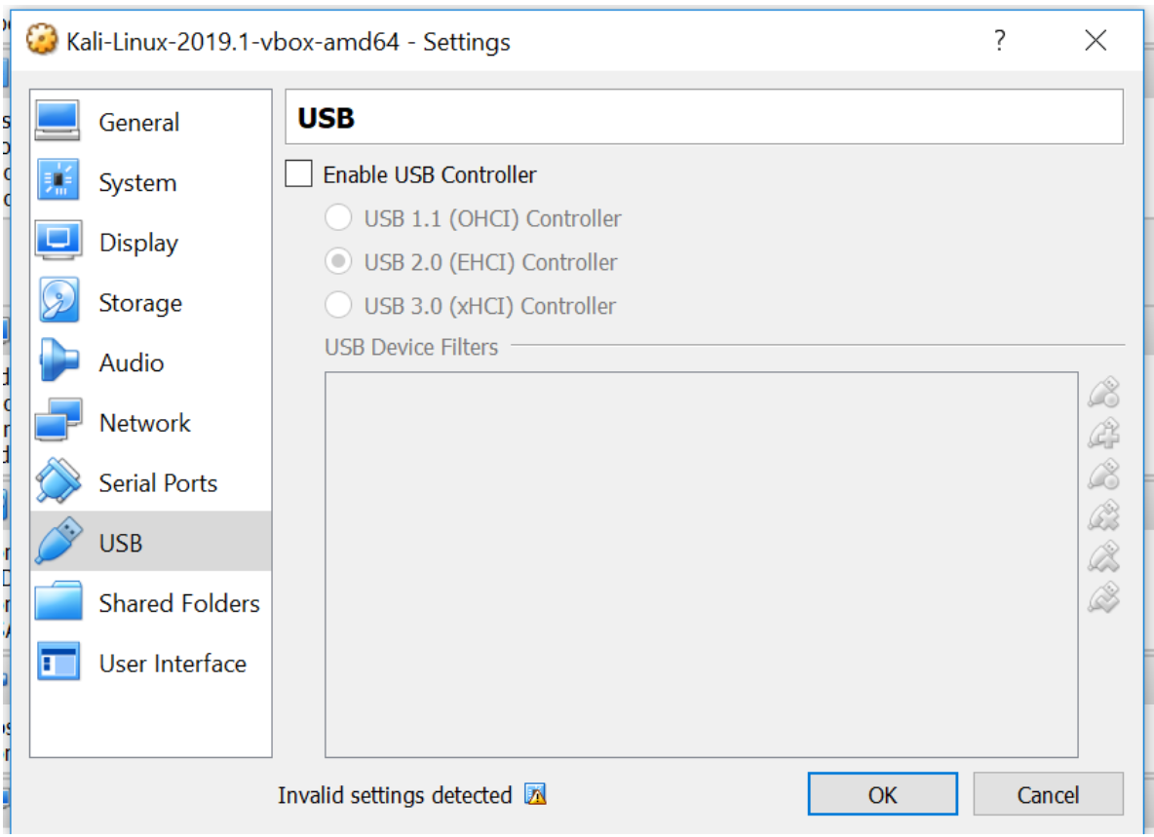

Now investigations can start :=)
Oh login is: and password is opposite…. . Did you see it on the way….?

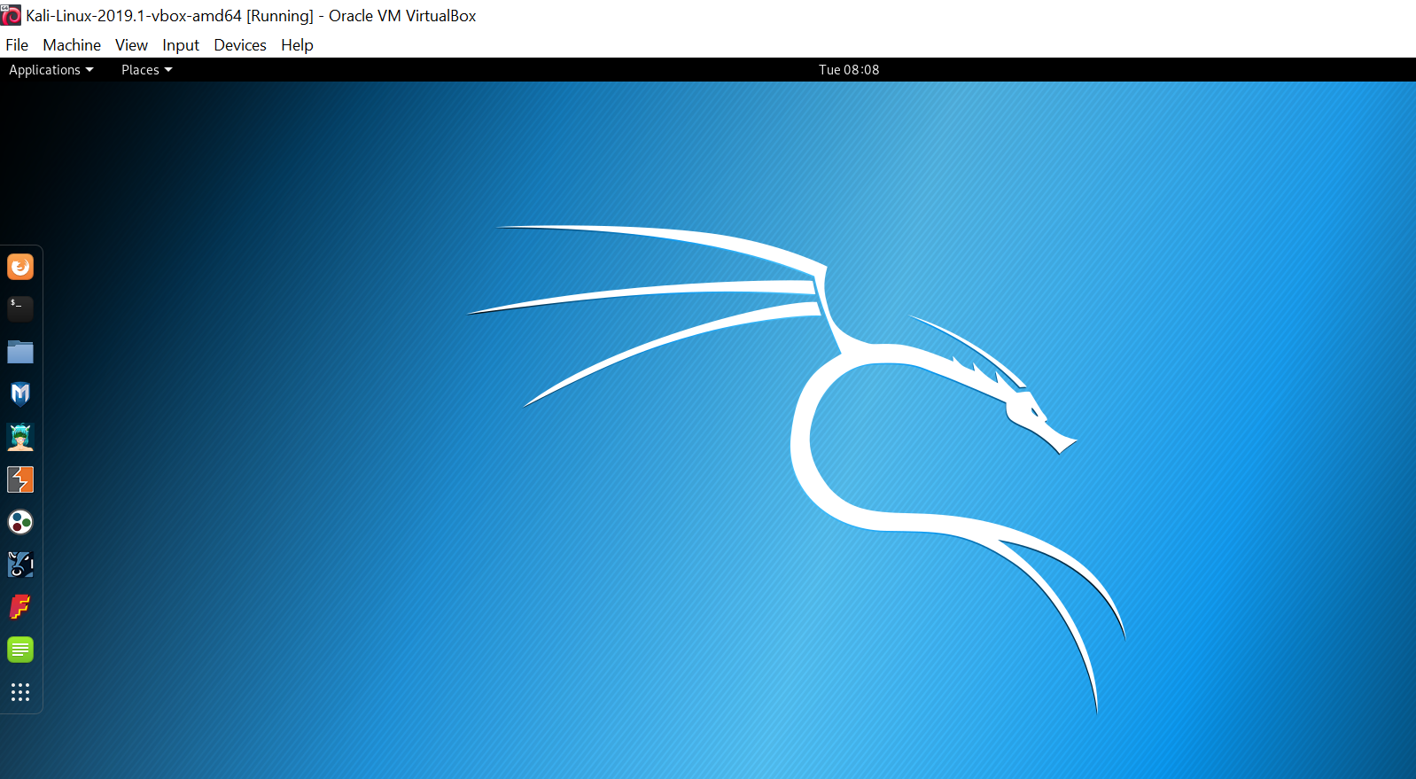

Assignment 2: nmap commands
nmap is a security port scanner provided by Kali Tool to discover hosts, services operating system detection on networks (map).
- Look up the nmap.txt document on teacher’s home page
- Try the commands one by one.

Assignment 3: Explore!
Get an overview of the tools.
Now explore some other possibilities in Kali Tools like

- Aircrack a popular tool for WEP(WPA/WPA2 cracking
- Or, whatever you find interesting…..

Form a group af 4 members. Choose 1-2 tools.
Investigate 3-4 hours, prepare a 15 minutes’ presentation nicely and then be ready to present the outcome for rest of the class.

It can take hours/weeks/months/years to become an expert

Appendix A: Installation of Kali Tools on Ubuntu

- Follow the following procedure:
Start Ubuntu.

sudo su
apt-get update
apt-get install git
git clone https://github.com/LionSec/katoolin.git && cp katoolin/katoolin.py /usr/bin/katoolin
chmod +x /usr/bin/katoolin
sudo katoolin

Now Choose: 1 Add Kali -> 1 Add Kali repositories -> 2 Update
Then enter: back ->
Choose: 2 View Categories -> 0 All
Choose menu 3) and 4) to install Kali menu
Exit by CTRL-C

Tips: For a detailed description go to:

http://www.tecmint.com/install-kali-linux-tools-using-katoolin-on-ubuntu-debian/

http://www.techrepublic.com/article/pro-tip-install-kali-linux-tools-on-ubuntu-with-this-easy-script/

Appendix A. some weeks/months/years

